**OPSC7311 PART 1 POE**

**PLANNING**

GROUP I

ST10092141 – Kgothatso Theko

ST10092072 – Karabo Yende

ST10092074 – Sibonelo Lukhele

ST10119431 - Kamvalethu Makatesi

**Planning**

Phase Tracer’s Software Requirement Document

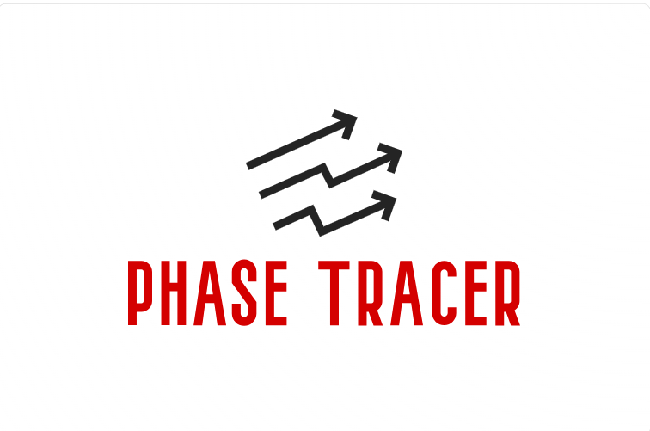

**Introduction**

The goal of the ‘Phase Tracer’ mobile is to help users effectively track and manage the amount of time they spend working on client projects. To also improve user productivity and motivation, it offers features including a timer, to-do list, task categorization, gamification components and more. This document serves an outline to the software development process for the innovate Phase Tracer Application. It will entail the overview of the application with innovative features, features which will cover the detailed list of requirements, user interface design, Gantt project plan, tools and conclusion.

**Overview**

Enabling users to precisely track their work hours, efficiently arrange assignments, and monitor their advancement over time is the aim of the Phase Tracer App. The software seeks to enhance productivity and maximize time management by also being user friendly. For this, the mentioned research done for Clockify, will be the innovative feature for the Phase Tracer’s layout/UI design and most features. Phase Tracker reporting feature has been an innovative feature taken from Timely as users may generate in-depth reports on project progress, time tracking, and more with it’s robust reporting and analytics tools (Timely, 2024). The ‘Pomodoro Timer’ Integration from the Toggl Track research will also be implemented to enable users to divide work into concentrated burst (Toggl Track, 2024).

**Features**

User Authentication

* Users can register username and password and may safely login.

Dashboard:

Timer Functionality

* Use a timer to record the start, middle, and end of work sessions.
* The Timer function and the Timesheets feature work together flawlessly to automatically fill in time entries. Instead of depending on the timer, users can choose to manually enter hours into the timesheet

To-Do-List

* Make and organize tasks in a to-do list.
* Assistance with the smooth continuation of tasks completed across several days.

Timesheet Entry Form

* Form containing fields for the selected category, description, start and end times, and date.
* There is a photo attachment option for every timesheet input.

Categorization

* Create and organize categories to classify timesheet entries. Timesheet Entry Form
* Form with fields for date, start time, end time, description, and category selection.
* Option to attach photos for each timesheet entry.

Daily Goal Setting

* Set minimum and maximum daily goals for hours worked.

Reports and Visualization

* View a list of all timesheet entries created during a user selected period.
* Access stored photos associated with timesheet entries, if available.
* View total hours spent on each category during the selected period.
* Graphical representation of total hours worked each day over the selected period, displaying min and max goal achievements.

**Platforms And Tools**

* **Development platform:** Android Studio
* **Programming Language:** Kotlin
* **Database:** Integrate with a suitable database for storing user data and timesheet entries.

**Project Plan**

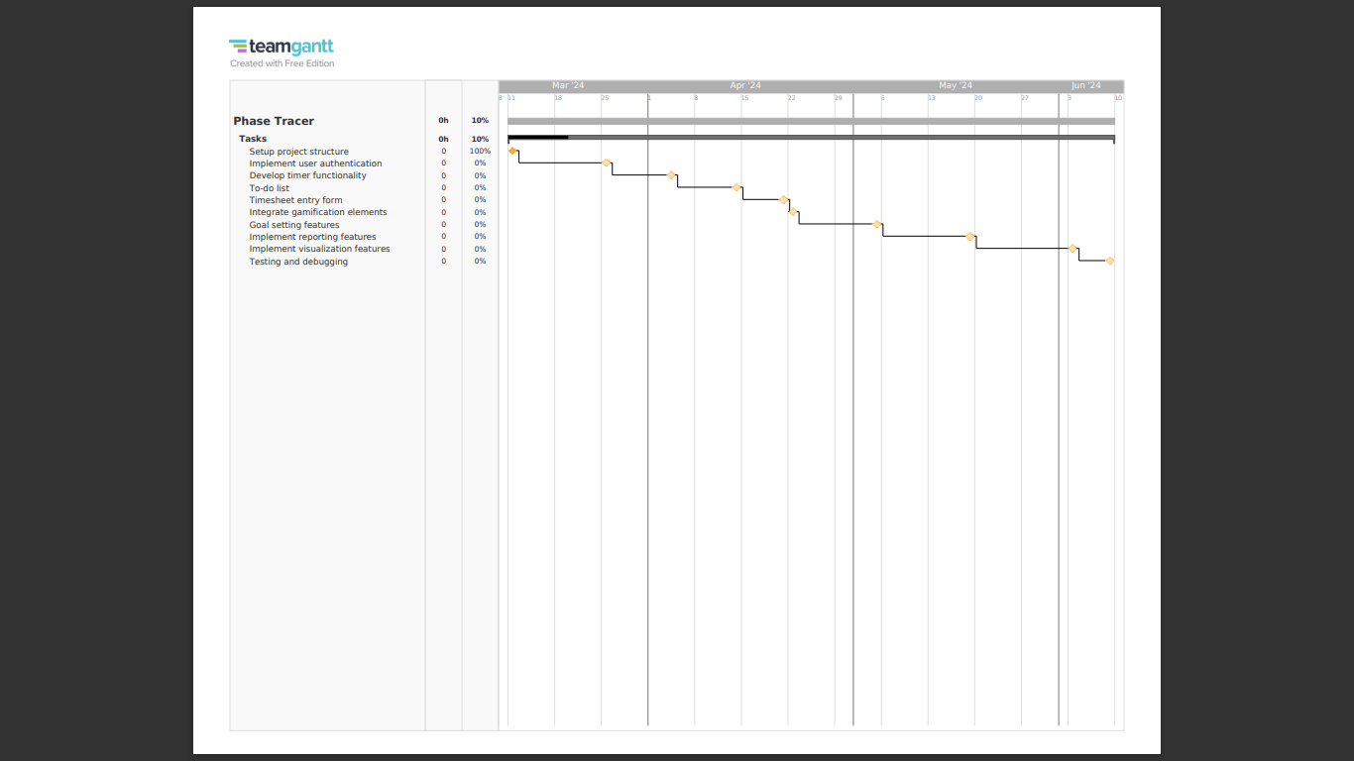

**Navigation Diagram**

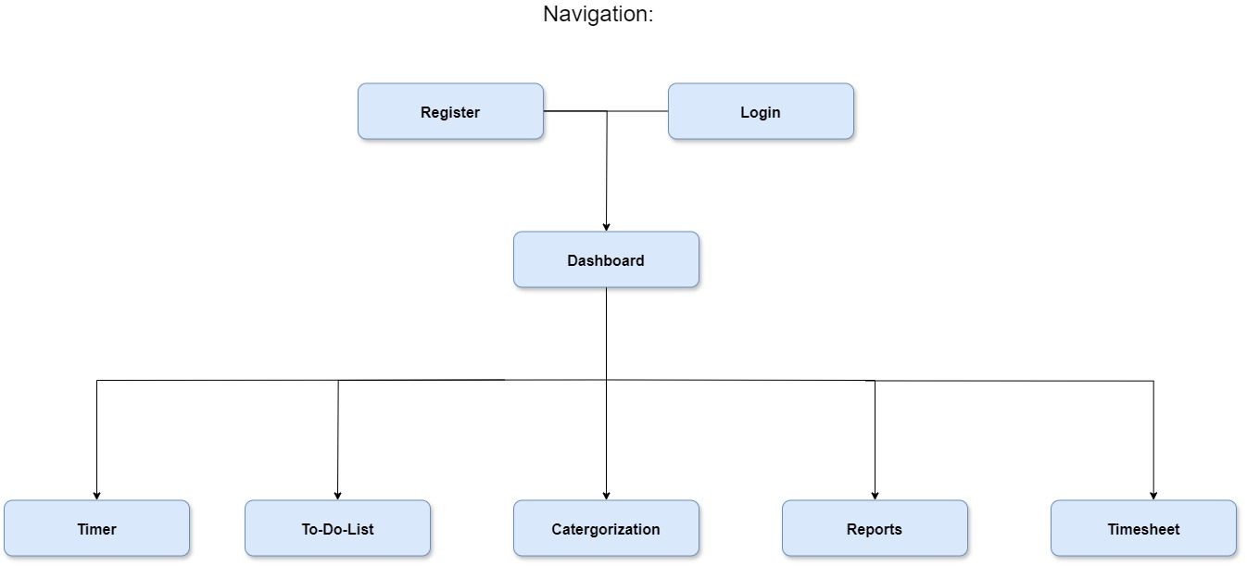

**Design**

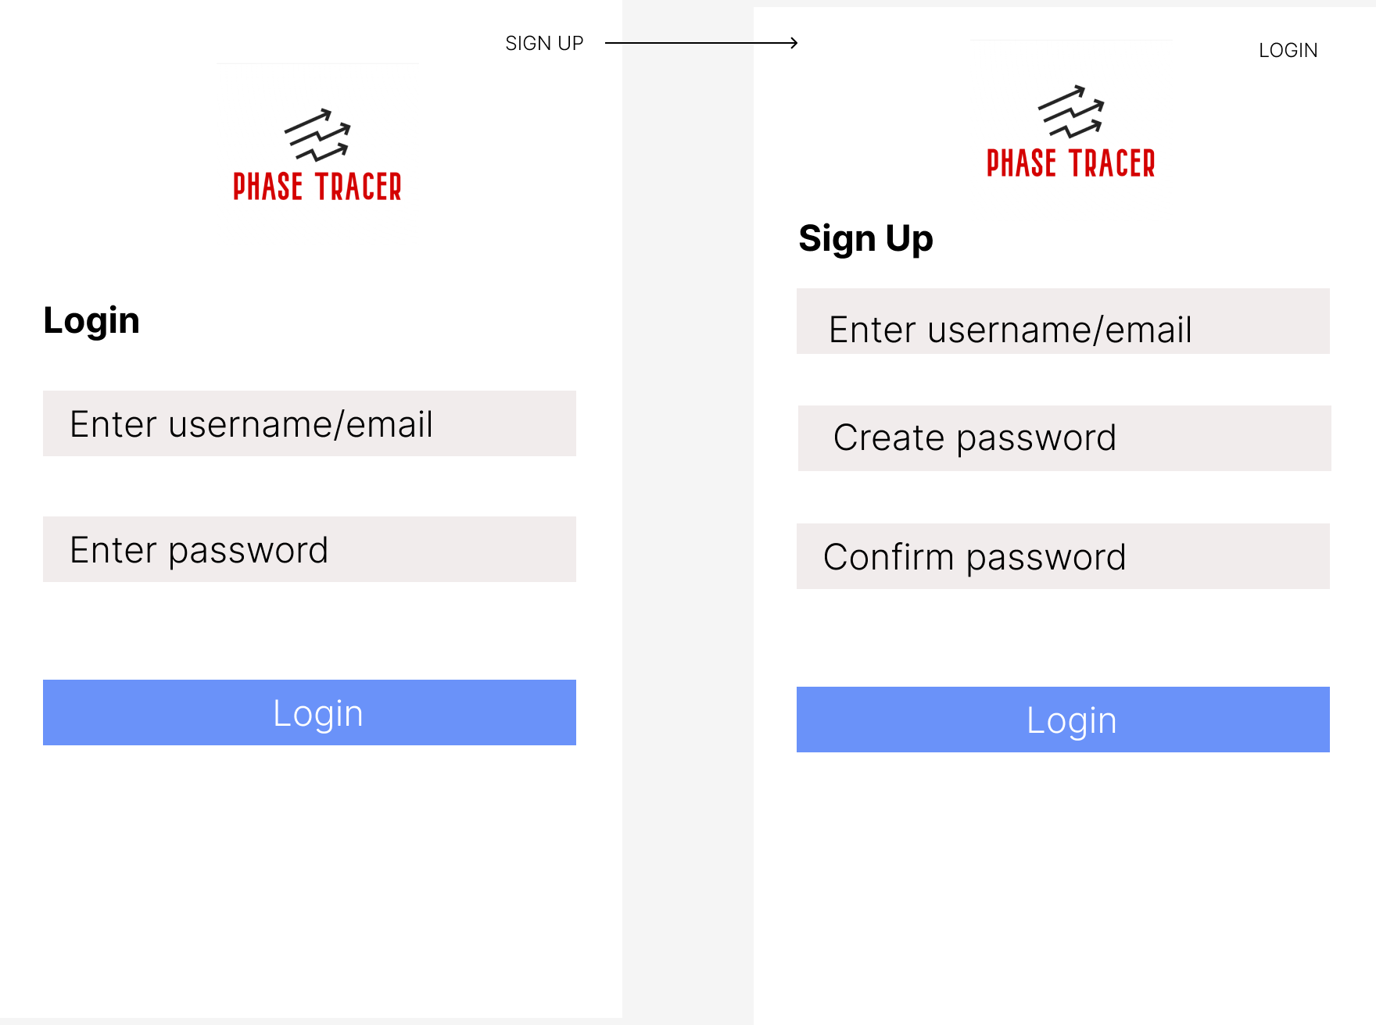

User Authentication

1. Login:

* The app opens on the login page, prompting users to enter their email address as their username and their password in order for them to log in.

1. Sign up:

* At the top right corner, a ‘SIGN UP’ feature is place, allowing users to redirect to the sign-up page.

Dashboard:

Timer Screen:

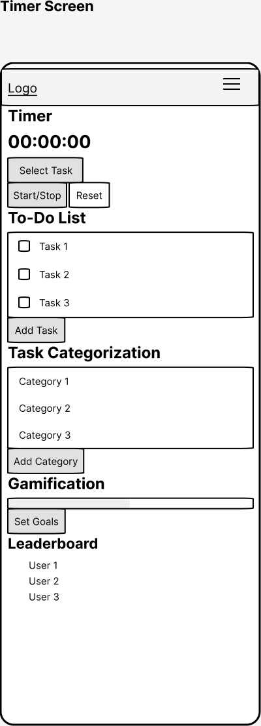

1. Top Navbar:

* The top navbar should contain the app logo on the left side.
* A menu icon that expands to provide connections to the various screens (Timer Screen, Calendar, Timesheet, To-Do List Screen, Task Categorization Screen, Reports Screen) should be located on the right side.

2. Timer Section:

* It should contain a timer that displays the time spent on the current task.
* There should be a start/stop button that starts and stops the timer.
* There should be a reset button that resets the timer to zero.
* There should be a dropdown menu that allows the user to select the task they are working on.

3. To-Do List Section:

* It should contain a list of tasks that the user needs to complete.
* There should be a button that allows the user to add a new task to the list.

4. Task Categorization Section:

* It should contain a list of categories that the user can assign to their tasks.
* Each category should have a color associated with it.
* There should be a button that allows the user to add a new category to the list.

5. Gamification Section:

* It should contain a progress bar that shows the user's progress towards their goals.
* There should be a button that allows the user to set their goals.
* There should be a leaderboard that shows the user's ranking compared to other users.

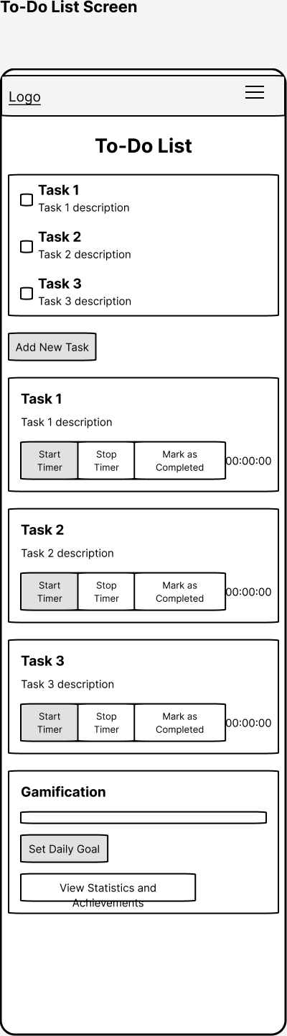

To-Do List Screen:

1. To-Do List Section:

* Each task should have a title and a description.
* There should be a button to add a new task at the bottom of the list.

2. Task Details Section:

* After the task is clicked, the task details section should have the task title, description, and a timer to record how much time is spent on the assignment.
* There should be a button to start the timer and a button to stop the timer.
* The timer should display the elapsed time and should be able to be paused and resumed.
* There should be a button to mark the task as completed and remove it from the To-Do List.

3. Gamification Section:

* The section should contain a progress bar that shows the user's progress towards their daily goal.
* There should be a button to set the daily goal.

Timesheet Screen:

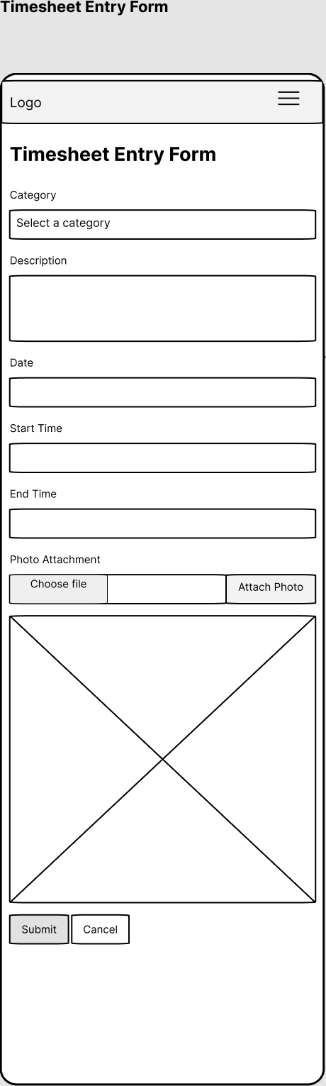

1. Category Section:

* The category section should contain a dropdown menu with a list of categories to choose from.

2. Description Section:

* There should be a text box in the description part where the user can describe the task or project they are working on.

3. Date Section:

* The date section should contain a date picker where the user can select the date of the timesheet entry.

4. Time Section:

* The time section should contain two time pickers, one for the start time and one for the end time.

5. Photo Attachment Section:

* The photo attachment section should contain a button labeled "Attach Photo" that opens the user's device camera or photo library. The selected photo should be displayed in a thumbnail next to the button.

6. Submit Button:

* The submit button should be located at the bottom of the form and should be labeled "Submit". When clicked, the form should be validated to ensure all required fields are filled out and the data should be saved to the database.

7. Cancel Button:

* The cancel button should be located next to the submit button and should be labeled "Cancel". When clicked, the user should be returned to the previous page without saving any data.

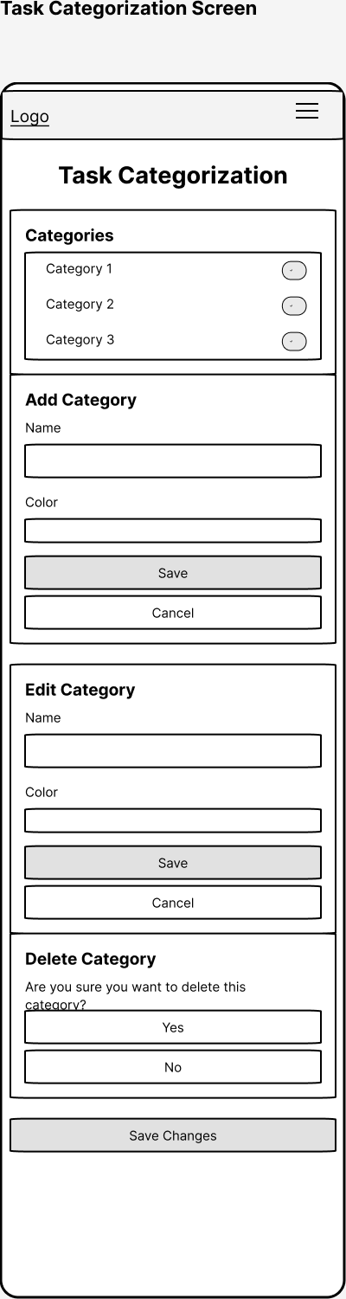

Task Categorization Screen:

1. Categories Section:

* It should display a list of categories that the user can choose from to categorize their tasks.
* Each category should have a name and a color associated with it.
* Clicking on a category should highlight it and display a checkmark next to it to indicate that it has been selected.
* The user should be able to select multiple categories at once.

2. Add Category Section:

* There should be a button labeled "Add Category" that allows the user to add a new category.
* Clicking on the button should display a form that allows the user to enter a name and choose a color for the new category.
* The form should have a "Save" button to update and a "Cancel" button to close form.

3. Edit Category Section:

* There should be an "Edit" button next to each category in the list.
* Clicking on the "Edit" button should display a form that allows the user to edit the name and color of the category.
* The form should have a "Save" button to update and a "Cancel" button to close form.

4. Delete Category Section:

* There should be a "Delete" button next to each category in the list.
* A confirmation window inquiring if the user is certain they wish to remove the category should appear when they click the "Delete" button.
* The confirmation message should have a "Yes" button and a "No" button.

5. Save Changes Section:

* There should be a "Save Changes" button at the bottom of the screen.

Reports Screen:

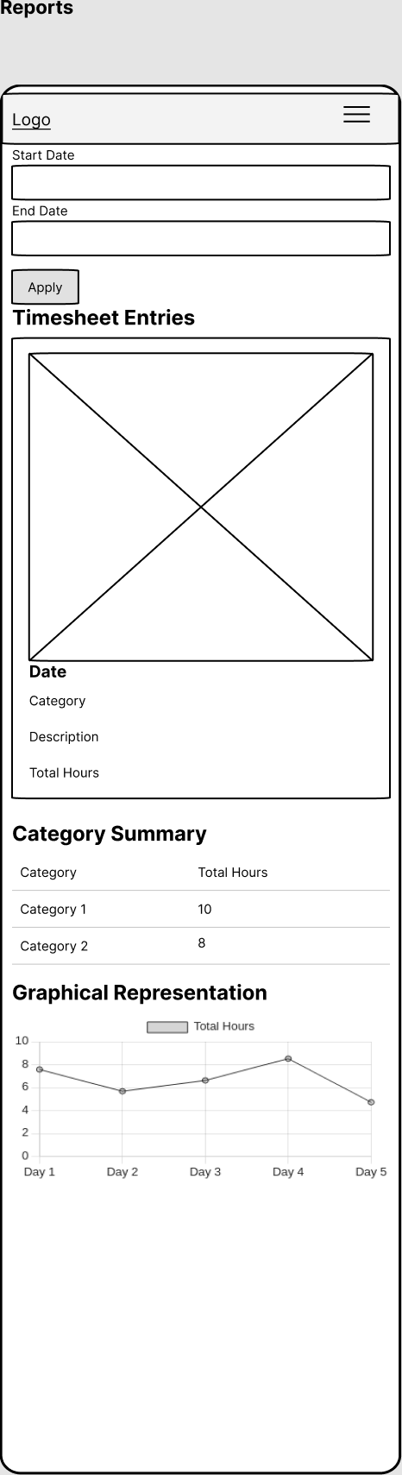

1. Timesheet Selection Section:

* This section should allow the user to select the time period for which they want to view the timesheet entries.

2. Timesheet Entries Section:

* A list of every timesheet entry made within the user-selected period need to appear in this area. The date, category, description, and total hours worked should all be visible for each submission. Should it be accessible, a thumbnail of the entry's photo ought to be included.

3. Category Summary Section:

* The total number of hours worked on each category over the chosen time frame should be shown in this column. Each category and the overall number of hours worked on it ought to be listed in a table.

4. Graphical Representation Section:

* For the chosen period, a graphical depiction of the total number of hours worked every day should be shown in this section. The minimum and maximum objective accomplishments ought to be shown.

**Conclusion**

With the help of the Phase Tracer App, users should be able to efficiently record and manage their work hours. The development process may be made more efficient by utilizing the features of Android Studio and Kotlin, which will produce an application that is both high-quality and user-friendly. The application will make an ongoing effort to improve user productivity and time management at work through iteration and improvement.

Reference List

Clockify. 2024. The most popular free time tracker for teams. [Online]. Available at: [Clockify™ - FREE Time Tracking Software](https://clockify.me/) [Accessed on 15 March 2024].

support.toggl.com. (n.d.). What is Toggl Track? [Online] Available at: [What is Toggl Track? | Toggl Track Knowledge Base](https://support.toggl.com/en/articles/2220404-what-is-toggl-track)

Timelyapp.com. (n.d.). Timely - Time Tracking Software. [Online] Available at: [Timely - AI-Powered Time Tracking Software (timelyapp.com)](https://timelyapp.com/) [Accessed on 25 March 2024].

Toggl Track. 2024. Frictionless time tracking software for teams. [Online]. Available at: [Toggl Track: Time Tracking Software for Any Workflow](https://toggl.com/) [Accessed on 25 March 2024].